#include <stdio.h>

int main() {
int n, i, days;
char name[50];
float watt, hours, energy, totalEnergy = 0;

printf("---- Household Energy Usage Calculator ----\n");

// Asking how many appliances to calculate
printf("Enter number of appliances used: ");
scanf("%d", &n);

// Loop to take input for each appliance
for(i = 0; i < n; i++) {
printf("\nEnter appliance name: ");
scanf("%s", &name);

printf("Enter wattage of %s (W): ", name);
scanf("%f", &watt);

printf("Enter duration used per day for %s (hours): ", name);
scanf("%f", &hours);

printf("Enter total number of days %s was used: ", name);
scanf("%d", &days);

/* Formula: Energy in kWh (units) =
(Watt / 1000) × Hours per day × Days */
energy = (watt / 1000) * hours * days;

printf("Energy consumed by %s = %.2f kWh (units)\n", name, energy);

// Add appliance energy to total
totalEnergy += energy;
}

// Display total consumption
printf("\n------------------------------------------------\n");
printf("Total Units Consumed for all appliances = %.2f units\n", totalEnergy);
printf("------------------------------------------------\n");

// Recommendation based on total energy consumed
if(totalEnergy > 300)
printf("Recommendation: Very High Consumption!\nUse power-saving appliances, reduce heavy usage, and avoid standby power.\n") ;
else if(totalEnergy > 150)
printf("Recommendation: High Consumption!\nTurn off appliances when not in use and avoid long continuous usage.\n");
else if(totalEnergy > 75)
printf("Recommendation: Moderate Consumption!\nUse LED bulbs and avoid standby power.\n");
else
printf("Recommendation: Excellent Consumption!\nKeep maintaining good power-saving practices.\n");

return 0;
}

OUTPUT:

Step1:

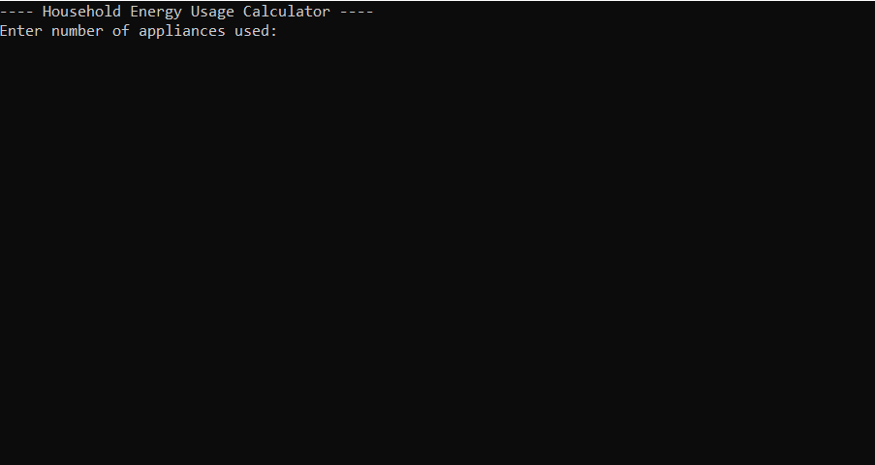

Step2:

